

Customers Satisfaction In

Food and Beverages Marketing

Name : Ashutosh Raina FIN NO.G3568506K ADHM-44  
Word Count:

INTRODUCTION

Hospitality is rendering g e n e r o u s a n d f r i e n d l y t r e a t m e n t o f v i s i t o r s a n d



g u e s t s o r h o s p i t a b l e t r e a t m e n t . I t i s abenevolent and pleasant

remedy to every guest or visitor.

Hospitality Interests

entertainment, offeringaccommodation, food beverages, and services withgoodwill and liberty.

A2B Restaurant - Adayar Ananda Bhavan

**M/s. Adyar Ananda Bhavan Sweets & Snacks is now a well-established brand in Southern India with a vision to spread globally across the world. The driving force behind the concern now is the two brothers Mr. K.T. Venkatesan and Mr. K.T. Srinivasa Raja to whom the baton of rich sweet tradition has been passed on by their late father K.S.Thirupathi Raja.**

A2B Vegetarian Restaurant and the Sweet Store is synonymous with a commitment to quality and a high degree of professionalism and use of state of the art technique in the manufacture of sweets, savories, snacks and wide varieties of Indian food. Reached the success peak being customer satisfaction as our mere motto. Our chain of branches speaks volumes about hygiene and service rendered by our organization and the trust and reliability that the customers have reposed. A2B is renown in India for serving authentic pure vegetarian food and delicious sweets and savories for patrons. Today Adyar Ananda Bhavan stood as the most renowned Vegetarian Restaurant in Chennai and also many other

places for its great ambience. Get yummy and bountiful food at an affordable price only at A2B..Adyar Ananda Bhavan is an example of hospitality sector that delivers employment to every individual of

others walks of life through a wide diversity in food and beverage services.

A2B RESTAURANT

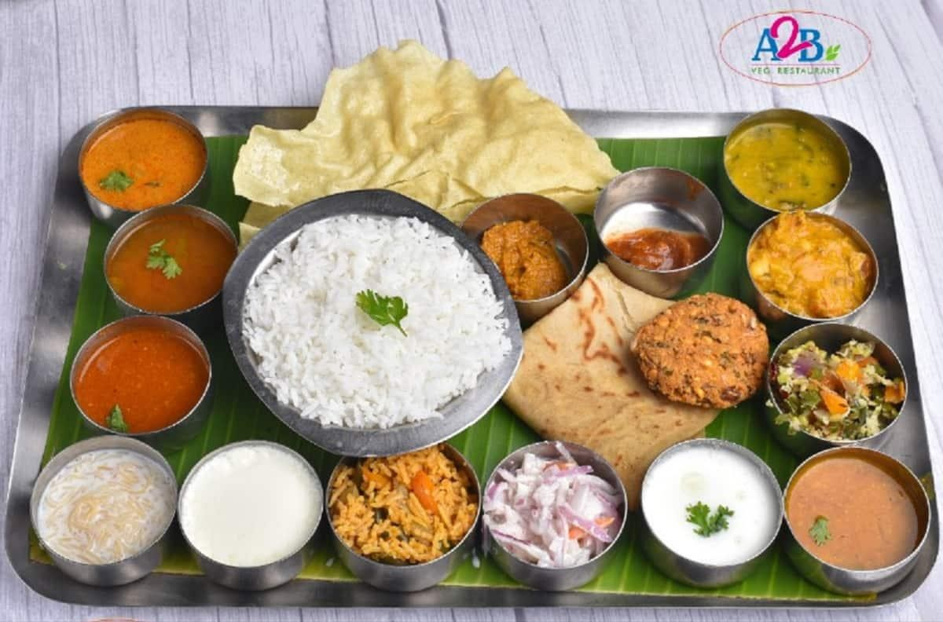

THE FACTORS INFLUENCING BEHAVIOR OF THE COSTUMER SATISFACTION

# CHARACTERISTICS OF SERVICE QUALITY

Measuring the impressionistic strands of service quality is pretty common . by a way collecting feedbacks and review through surveys or face to face interaction, social media accounts review is anew norms now a days and these is to understand more your costumers needs and level of service satisfaction. its a tool cover what SERVQUAL avow are the five strands or elements of a excellent service quality:

RELIABILITY:- The capability to convey the pledged service in an accordant preciseapproach RESPONSIVENESS:- How inclined the employees are to render a prompt service. TANGIBLES:- the aspect of the fallowing in example building, equipment, website andorganization or employees.

ASSURANCE:- The proficiency degree and politeness of the staff or the employee andwiden they created faith and confidence.

EMPHATHY:- The ability to imagine how another person is feeling and so understandhis/her mood

# DIMENSIONS OF SERVICE QUALITY

Tangibles:- Includes the physical appearance of the physical service facilities, the equipment, the personnel who do the servicing, the communication materials and all tangible elements of service provider facilities or surroundings

Responsiveness:- The willingness of the service provider to be helpful, be prompt in

providing services, and to respond to customers’ requests, problems or complaints

Service reliability:- Differs from the product reliability in that it relates to the ability of the

service provider to perform the promised service dependably and accurately Empathy:-

Caring, individual attention paid to customers by the service firm to meet each customer’s demands properly.

Assurance:- The knowledge and courtesy of employees and their ability to inspire trust

and confidence – creating trust and confidence will gain the customers’

loyalty

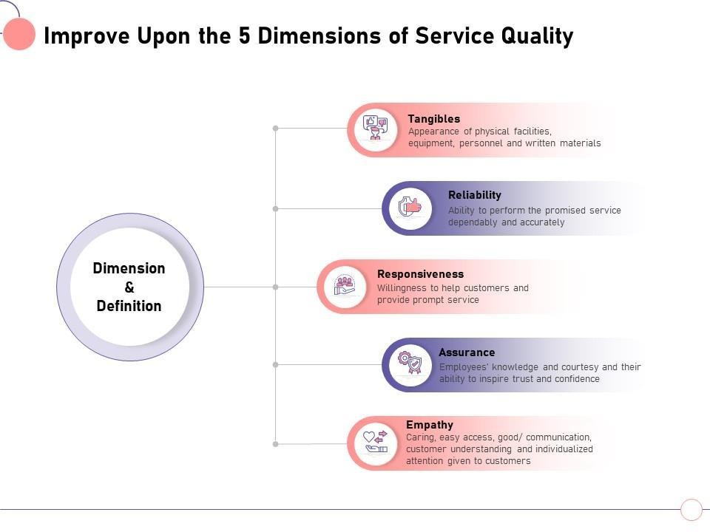

# DIFFERENCE BETWEEN QUALITATIVE ANDQUANTITATIVE

**APPROACH**

### Qualitative data involves a descriptive judgment using concept

words instead of numbers. Gender, country name, animal species,and emotional state, feelings, and opinions are examples of

### qualitative information.

Quantitative data involves a measurable quantity, that is

### numbers are used. Some examples are temperature, time, the amount spent, number of units bought and hours spent on the computer.

DIFFERENCE BETWEEN QUALITATIVEAND QUANTITATIVE APPROACH



1. THE MAIN SERVICE QUALITY DIMENSION ANDTHEIR PRIORITIZATION

**RELATIONSHIP BETWEEN SERVICE QUALITY AND CUSTOMER**

It is pretty obvious that diners or consumers are important investors in organization and their contentment and satisfaction is the main focus of priority to management of A2B Restaurant. Diners satisfactions has been a target point of a great interest. The quality of service has become an aspect of patrons high value of satisfaction. The main goal is to render an excellent service in order to gain that customersatisfaction that may equal or exceed the diner’s expectations. This is to bring a general positive good relationship between the restaurant and the customer service quality. All the dimensions of service quality where identified core factor in molding customer satisfaction.

**THE SERVICE QUALITY AFFECTS THE CUSTOMER SATISFACTION INFINE DINING RESTAURANT**

Restaurant ambiance can have a big impact to image and influence to diners and costumer level of satisfaction especially in restaurant sector. This can be amarketing tool also to attracts more customer. Although food and service quality are important, visually pleasing restaurant environment will also determine to a high degree of overall customer satisfaction in food and beverage industries .the surrounding condition can have a significant impact onperception of total quality, which turn to affect customer satisfaction towards a particular restaurant. There is a direct rope between environment and customersatisfaction in fine dining restaurant.

**THE LINK BETWEEN SERVICE QUALITY AND CUSTOMERSATISFACTION**

## Customer satisfaction is means as the customers’ post-purchase judgment between pre- purchase what do they expect and how they received. The relationship between service quality and customer satisfaction has been tackled several times from past papers during decades of years. a lot of studiesthat presents that service quality has a positive relationship with customer satisfaction. Service quality, therefore, has become one of the censorious factors for satisfying and retaining a bid patrons in every sectors, industry and

Many more. Many experts highlight that excellent service quality ended in full customer satisfaction and loyalty with everything you offer or selling a satisfied customer will have the preparedness to spread the recommendations someoneelse, reduction in negative feedbacks or complaints and the profit can achieve

## the customer retention.

1. RELATIONSHIP BETWEEN SERVICE ANDQUALITY SATISFACTION

**SIGNIFICANT RELATIONSHIP BETWEEN ENVIRONMENT ELEGANCEIMPACT POSITIVELY TOWARDS CUSTOMER SATISFACTION**

The total ambiance in restaurants stands the significant part in leveling up profit performance and the customer’s intention to avail and subscribe products or foods as well as customer satisfaction. In recent year eating habit in a more descent a pleasing restaurant environment fluctuate rapidly. The quality of service and the physical environment (such as the interiors that includes the colors deco and staff) in food establishments needs to be acceptable. Nevertheless, the physical environment in the restaurant industry has a significant impact on customer satisfaction and the perceived best quality of the well fulfilled and delivered service. It was determined that the perceived physical environment had a positive and directeffect on customer satisfaction and also that customer satisfaction had a strong positive effect on the intention to visit again.

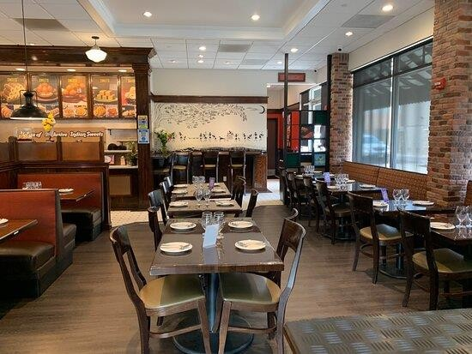

*A2B RESTAURANT IN A MODERNCONTEMPORARY AMBIENCE*

**SERVICE QUALITY AND ITS MODEL**

Service quality is broadly sighted as the product of the service delivery system.Service quality is linked to patron’s high satisfaction.



Three decades ago, a small sweet shop was started by Late K.S. Thirupathi Raja, in the metropolis of Chennai. This same shop has now flowered into multiple branches that dot the length and breadth of Chennai as well as its neighbouring cities.

M/s. Adyar Ananda Bhavan Sweets & Snacks is now a well-established brand in Southern India that continues to grow with a vision to capture the global market. The baton of this sweet legacy was passed on by K.S. Thirupathi Raja to his sons, Mr. K.T. Venkatesan and Mr. K.T. Srinivasa Raja who now act as the driving force behind A2B.

It is a way and a method to apprehend and scale the service quality experienced by clients or customers. Initially, highlight was on the development of quality systems in the sector output quality. Over time, it became plus and added mustand key to level up the quality of allied services. Ameliorate service quality willgive establishment or organizations aggressive advantage to competitors. In addition, service in general became more major tool, and as a result, the SERVQUAL Model had a momentous impact in the eighties. Back then, measuring service was abstract and not easily quantifiable. The SERVQUALModel is primarily a qualitative analysis.

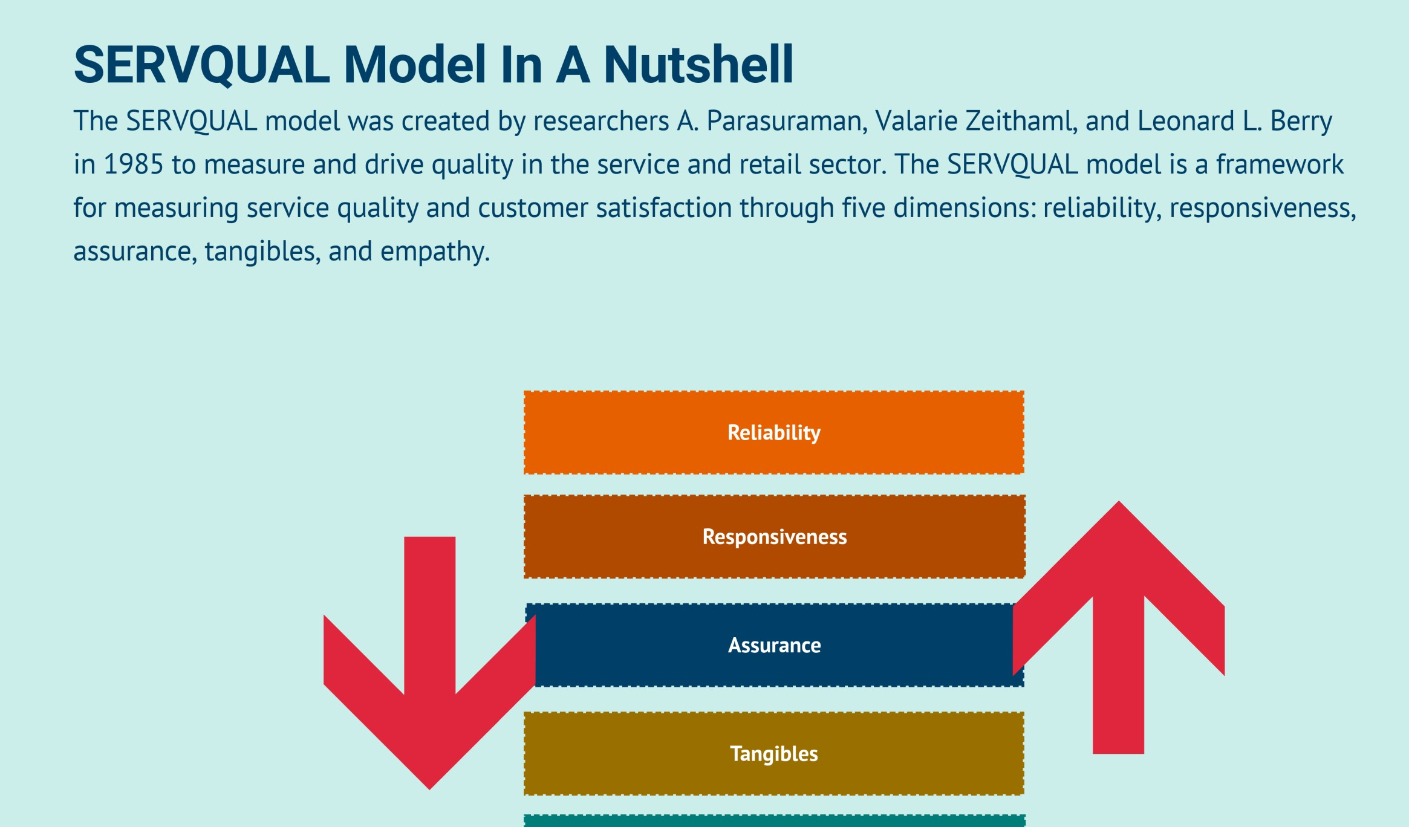

**MEASURING SERVICE QUALITY BY SERVQUAL**

Service quality in the hospitality industry becomes one of the most keyfactors for gaining a sustainable competitive edge and customers’ assertive in the highly competitive bazaar, and therefore, service quality can give the hospitality industry a prominent stage to create emulous differentiation for organizations. Many good profit and can be achievedaccomplished by service quality such as founding a priority customer satisfaction donating to business reputation , entrenching customer loyalty, and offering a competitive advantage to a establishment .

Service quality can be defined as the expand to which the service achieved the high needs or outstanding expectations of the customers or conceptualized it as the overall impression of customers as regardsthe weakness or excellence of the service.

SERVQUAL MODEL

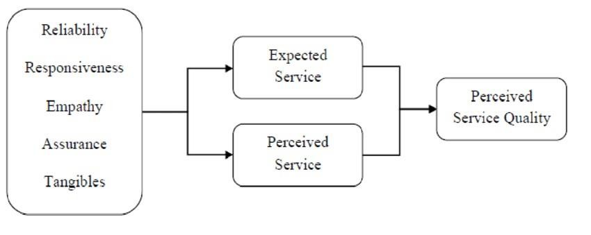

CONCLUSION

My qualitative analysis of the hospitality industry manifest that the magnitude of customer contentment and satisfaction is outstanding by same looking at the evaluation and collecting feedbacks in the single services. Managing the organization through human resource management in specific hold forth to be especially productive in events and restaurant sectors . Although A2B is a small structure they manage to increase the customer satisfaction by pure analyzing the customer needs. In general, the main factor which limits the A2B Restaurant to achieve higher customer satisfaction levels is the goals i standardization of services that avoid the possibility to customize the offer for definite guest needs. The outcome displays thatthere’s strong relationship between service quality and customer satisfaction. The study believe that both service and food quality would have a positive sway on customer satisfaction, which in turn would positively affect customer retentiveness. In conclusion, my study found a significant relationship between service quality and food quality and customer satisfaction. The results of this study suggest that service quality notonly enhances customer satisfaction, but also leads to customer retention. A2B Restaurant study shows that

over all facility, interior , exterior beauty have impactful effects in attracting customers and not only that there is a positive effects in customers satisfaction . It covered the reviews of literature on food quality, service

quality and restaurant environment that will lead to customer satisfaction towards revisit intention in fast food restaurants.

THANK YOU